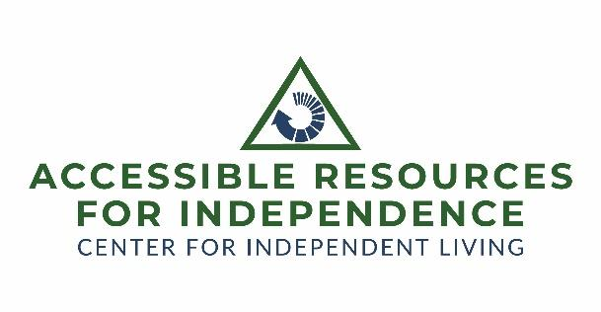
Leadership Opportunity starting June 1, 2026

Position: Executive Director, part-time
Organization
Founded in 2010, Accessible Resources for Independence (ARI) is a non-profit, federally designated Center for Independent Living (CIL), one of 7 such organizations in Maryland with an annual budget of $400,000. Our mission is to maximize the independence of people with disabilities, so they enjoy self-directed, productive lives. We do this by providing consumer-directed services, including peer mentoring and support, information and referral, independent living skills training, advocacy, and transition assistance for both youth leaving high school and individuals moving from nursing facilities to homes of their own.
ARI is a mission-driven organization that actively practices its disability-rights values of inclusion and equal access, during a time when it is facing strong headwinds from funding sources. We are looking for an ED to navigate ARI in this climate and get ARI to a more stable financial footing.
FOR FULL JOB DESCRIPTION click here.
Closing date: April 15, 2026.
Position
Part-time: 25 hours a week
Reporting to the Board of Directors, the Executive Director will have overall strategic and operational responsibility for ARI’s staff, programs, expansion, and execution of its mission. They will ensure proper administration of contracts, budgets, finances, personnel, operations, agency and contract goals, resource development, and marketing. They will carry out the policies and direction established by the Board of Directors and ensure that ARI complies with all the laws and requirements that govern Centers for Independent Living (CILs).

QUALIFICATIONS
BA/BS in Social Sciences, Public Administration, or Business Administration or related field and five years’ experience in the nonprofit sector as a senior manager, or experience in a related endeavor from which the necessary job-related knowledge, skills, and abilities for the position have been obtained, are required.
Experience providing services to people with disabilities, and knowledge of and commitment to the independent living philosophy. Personal experience with disability is preferred.
Program development and management experience in a Center for Independent Living or other disability-related, grassroots organization.
Thorough understanding of the regulatory requirements for non-profits.
Experience with government contracts, meeting multiple deadlines with specific data-based outcomes, and delivery of results through detailed reporting.
Persuasive and passionate oral and written communication skills.
Experience with financial oversight and management.
Excellent organization skills and flexibility, with the ability to successfully multi-task, prioritize projects, and meet deadlines, often on short notice.
Experience in recruiting, training, and supervising staff and volunteers.
Ability to coach staff and develop a high-performance, cohesive team.
Proficiency in grant writing and management, and fundraising efforts.
ATTRIBUTES
Leadership: Taking initiative, motivating others, and managing projects.
Flexibility/Adaptability: The ability to pivot, take on new tasks, to learn new things, and manage changing circumstances.
Resilience: The capacity to manage stress and persist through challenges.
Teamwork/Collaboration: Working effectively within a group to achieve shared goals, and to interact well with others.
Work Ethic/Reliability: Being dependable, consistent, and committed to high-quality work.
Communication Skills: Articulates ideas clearly and effectively, to convey information, and to gather and process information.
Problem-Solving/Resourcefulness: Identifying issues and creating solutions using available tools.
Integrity/Conscientiousness: Acting ethically and paying attention to detail.

REQUIREMENTS
Must pass a criminal background check.
Must have access to transportation and the ability to travel throughout Maryland.

SALARY AND BENEFITS INCLUDE:
Salary $48,750
Paid time off and holidays earned on a prorated basis
Health and Retirement benefits available
All resumes, cover letters, and evidence of minimum qualifications, should be submitted to: ExecutiveSearch@arinow.org. Individuals requiring reasonable accommodations during the hiring process should notify the chair of the search committee at the time of application.
The Executive Director is expected to start June 1, 2026, or shortly thereafter.

Accessible Resources for Independence is an equal opportunity employer committed to hiring staff who reflect the diversity of the community. Persons with disabilities, women, veterans, and minorities are strongly encouraged to apply. Moreover, under federal law, ARI has an obligation to “ensure that the majority of the staff, and individuals in decision-making positions . . . are individuals with disabilities.” 29 U.S.C. § 796f-4(c)(6).

